Organizational Management Promotion
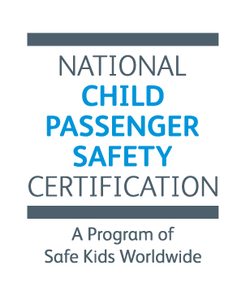
Prepayment Bonus!
Prepay for your organization’s certification fees and get a bonus 10%.

We'll give your organization a bonus 10% for prepayment of at least $2000. These funds can be used to pay for any certification fee, including course registration and recertification.

Simply let us know you want to take advantage of this opportunity by
including this information sheet with your check.

Organization/Org ID:
Organization Manager/Contact:
Contact email:
Contact daytime phone:
Amount enclosed:

Please let us know what PO# to enter. This is the number the Organization Manager or your affiliates will enter to use the funds.

Return with payment to:
CPS Certification
Safe Kids Worldwide
1255 23rd St NW, Suite 400
Washington, DC 20037

Questions? Kerry: 202-662-0639, kchausmer@safekids.org

