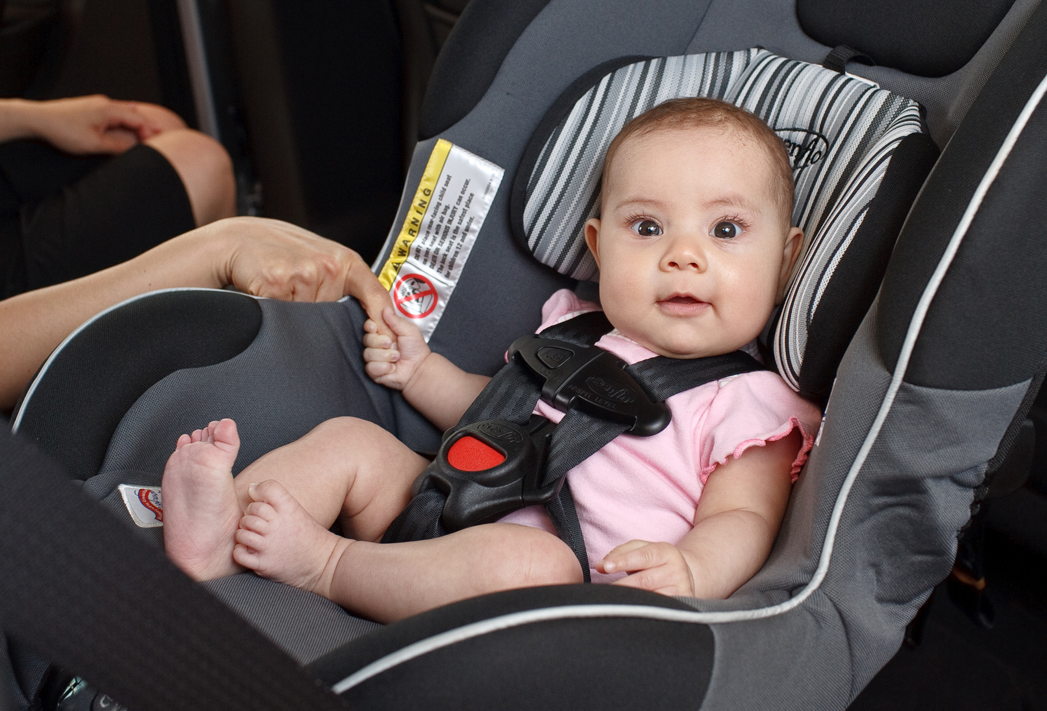
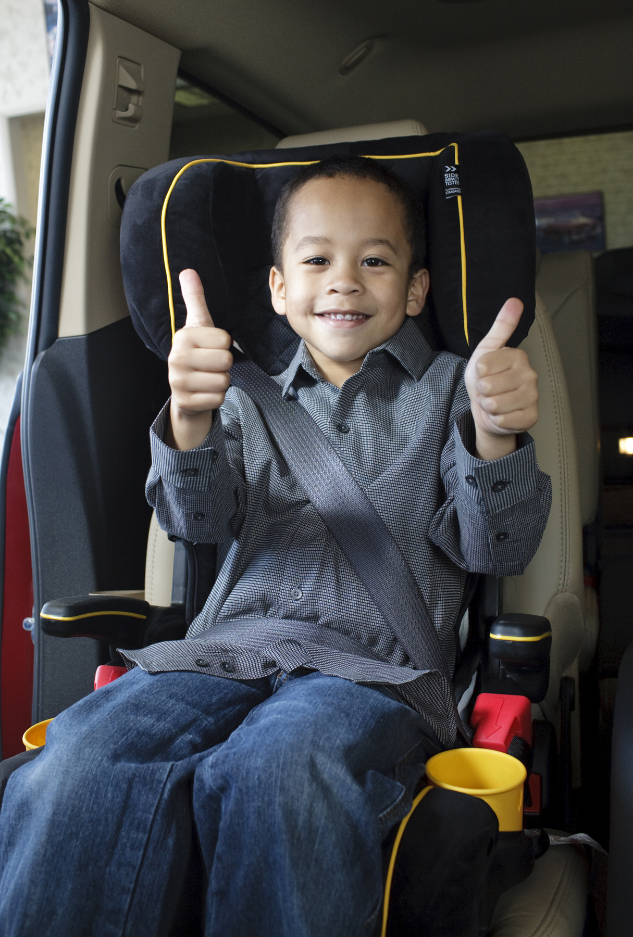
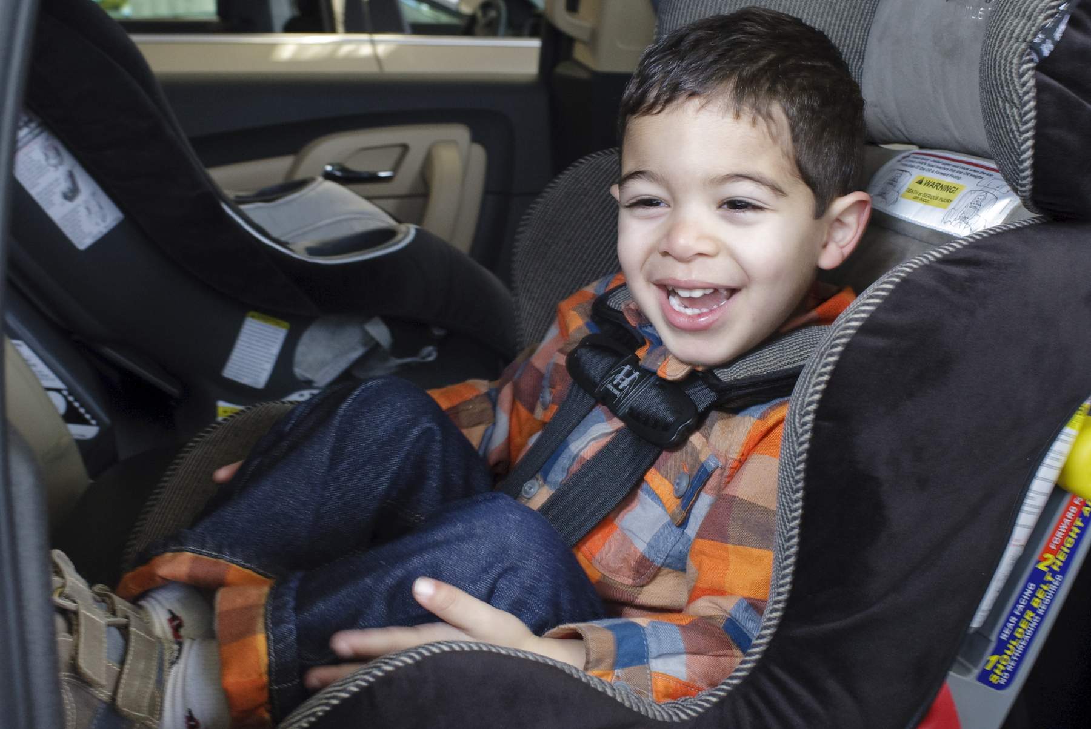
[Day of the Week, Date]

Virtual Child Passenger Safety Class
  - Taught by a Nationally Certified Child Passenger Safety Technician
  - on the basics of child passenger safety.

[Time]
[Add instructions – choose an option]
Please [call/email/register] to register for the class at [phone #, link, email]
OR
Please join at [link, access code, and/ or password]

Contact: [Name, Email, Phone Number]

[Add special instructions if applicable]
- Space is limited
- [Link] to pre/post evaluation
- [Link] to homework
- [Link] to welcome letter [if open class]

Learn how to select and use car seats correctly for children in
[list only those that are applicable:]
rear-facing, forward-facing and/or booster seats.
Learn about what’s next as your children transition
to a new car seat or booster seat.

[Logos]

