**Notice of Disclosures**

National Child Passenger Safety Technician Certification Program

ADD Course ID

ADD Dates

Criteria for Awarding Contact Hours:

Sign in/register on attendance roster daily

Contact hours awarded for full participation during standardized course

Completion and submission of evaluation form

Conflict of Interest: No conflict of interest exists for any individual in a position to control the content of this educational activity.

Planners:

National Child Passenger Safety Board 2019-2020

Emeritus Board Member: Thelma Kuska, RN

Commercial Support: None

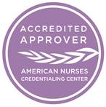

*This nursing continuing professional development activity was approved by the Emergency Nurses Association, an accredited approver by the American Nurses Credentialing Center’s Commission on Accreditation.*