Organizational Management Promotion
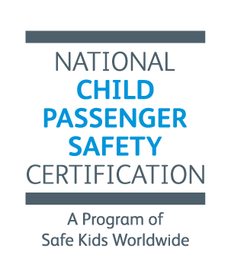
Prepayment Bonus!
Prepay for your organization’s certification fees and get a bonus 10%.

We'll give your organization a bonus 10% for prepayment of at least $2000. These funds can be used to pay for any certification fee, including course registration and recertification.

Simply let us know you want to take advantage of this opportunity by including this information sheet with your check.

Organization/Org ID:
Organization Manager/Contact:
Contact email:
Contact daytime phone:
Amount enclosed:
The amount plus 10% will be applied to an Evoucher. The EVoucher (EV) is a line of credit with Safe Kids.
Once processed, Safe Kids will send you an email confirming the funds have been applied and provide the EV#, which the Organization Manager or your affiliates will enter to use the funds.

Return with payment to:
CPS Certification
Safe Kids Worldwide
1301 Pennsylvania Ae NW #1000
Washington, DC 20004

Questions? Kerry: 202-662-0639, kchausmer@safekids.org

